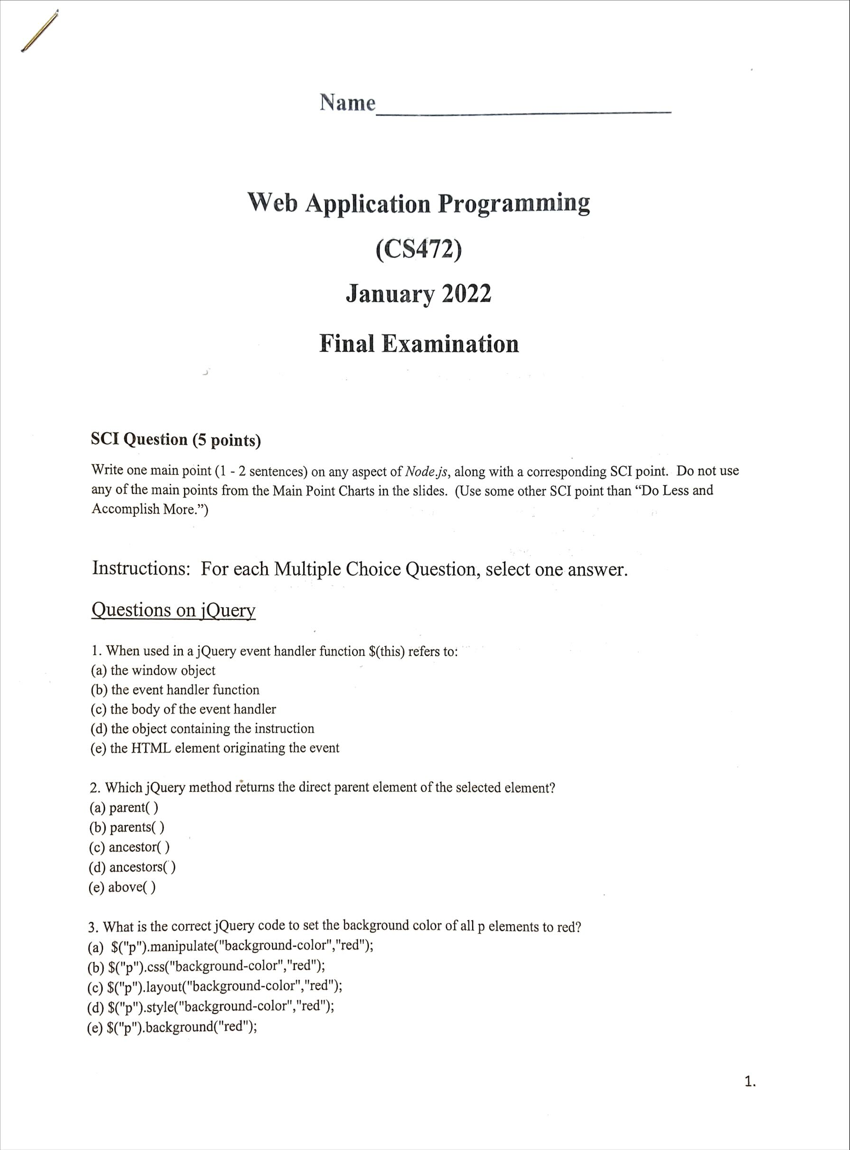

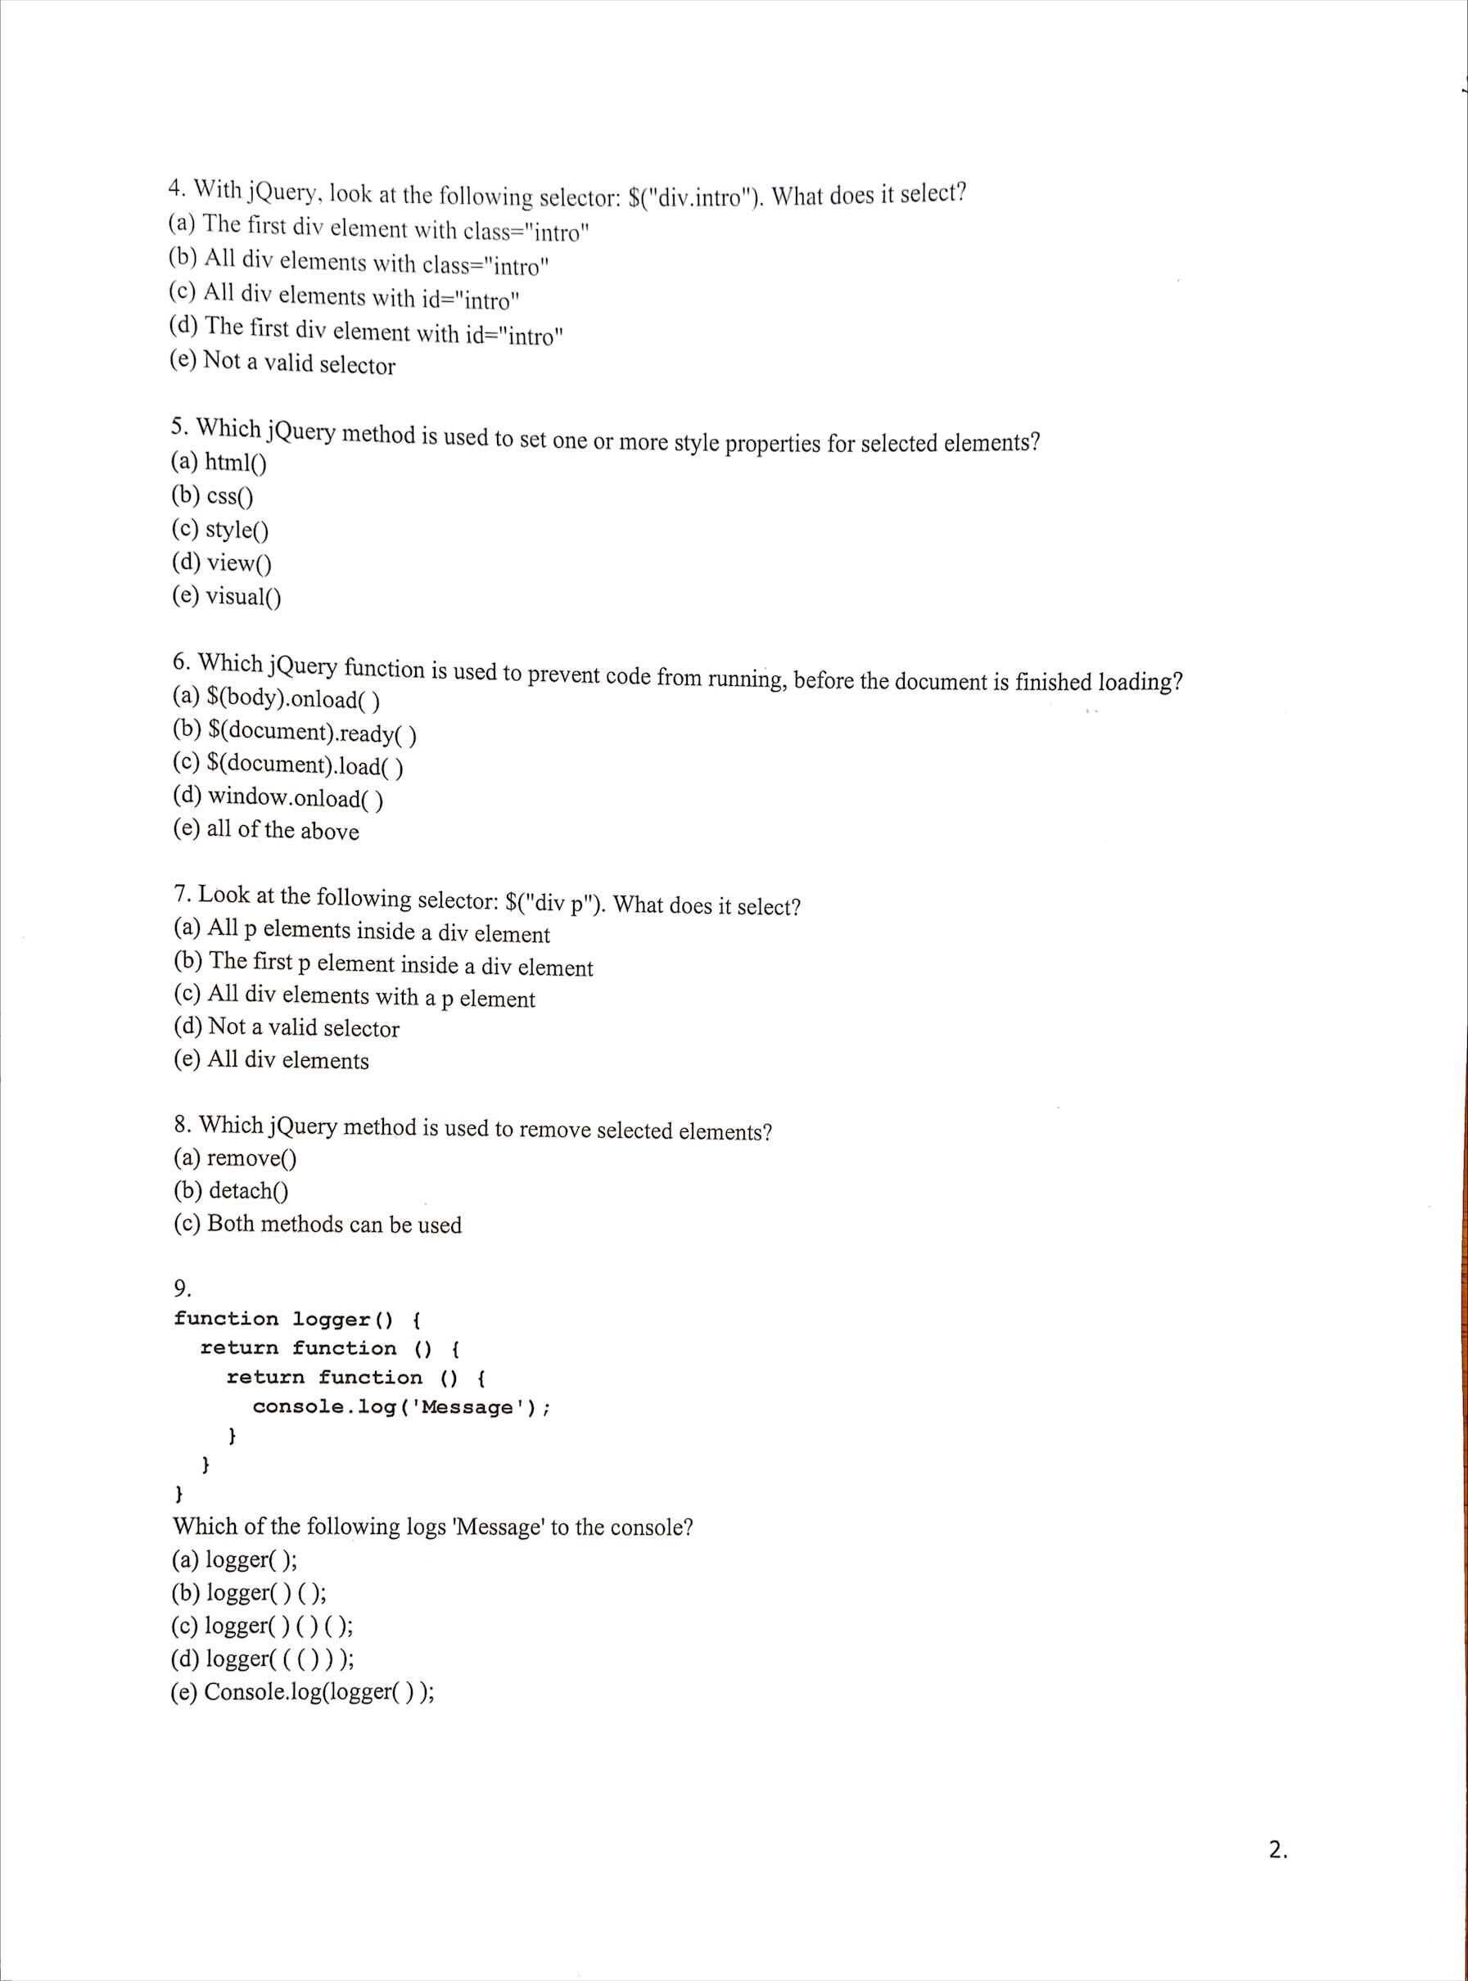

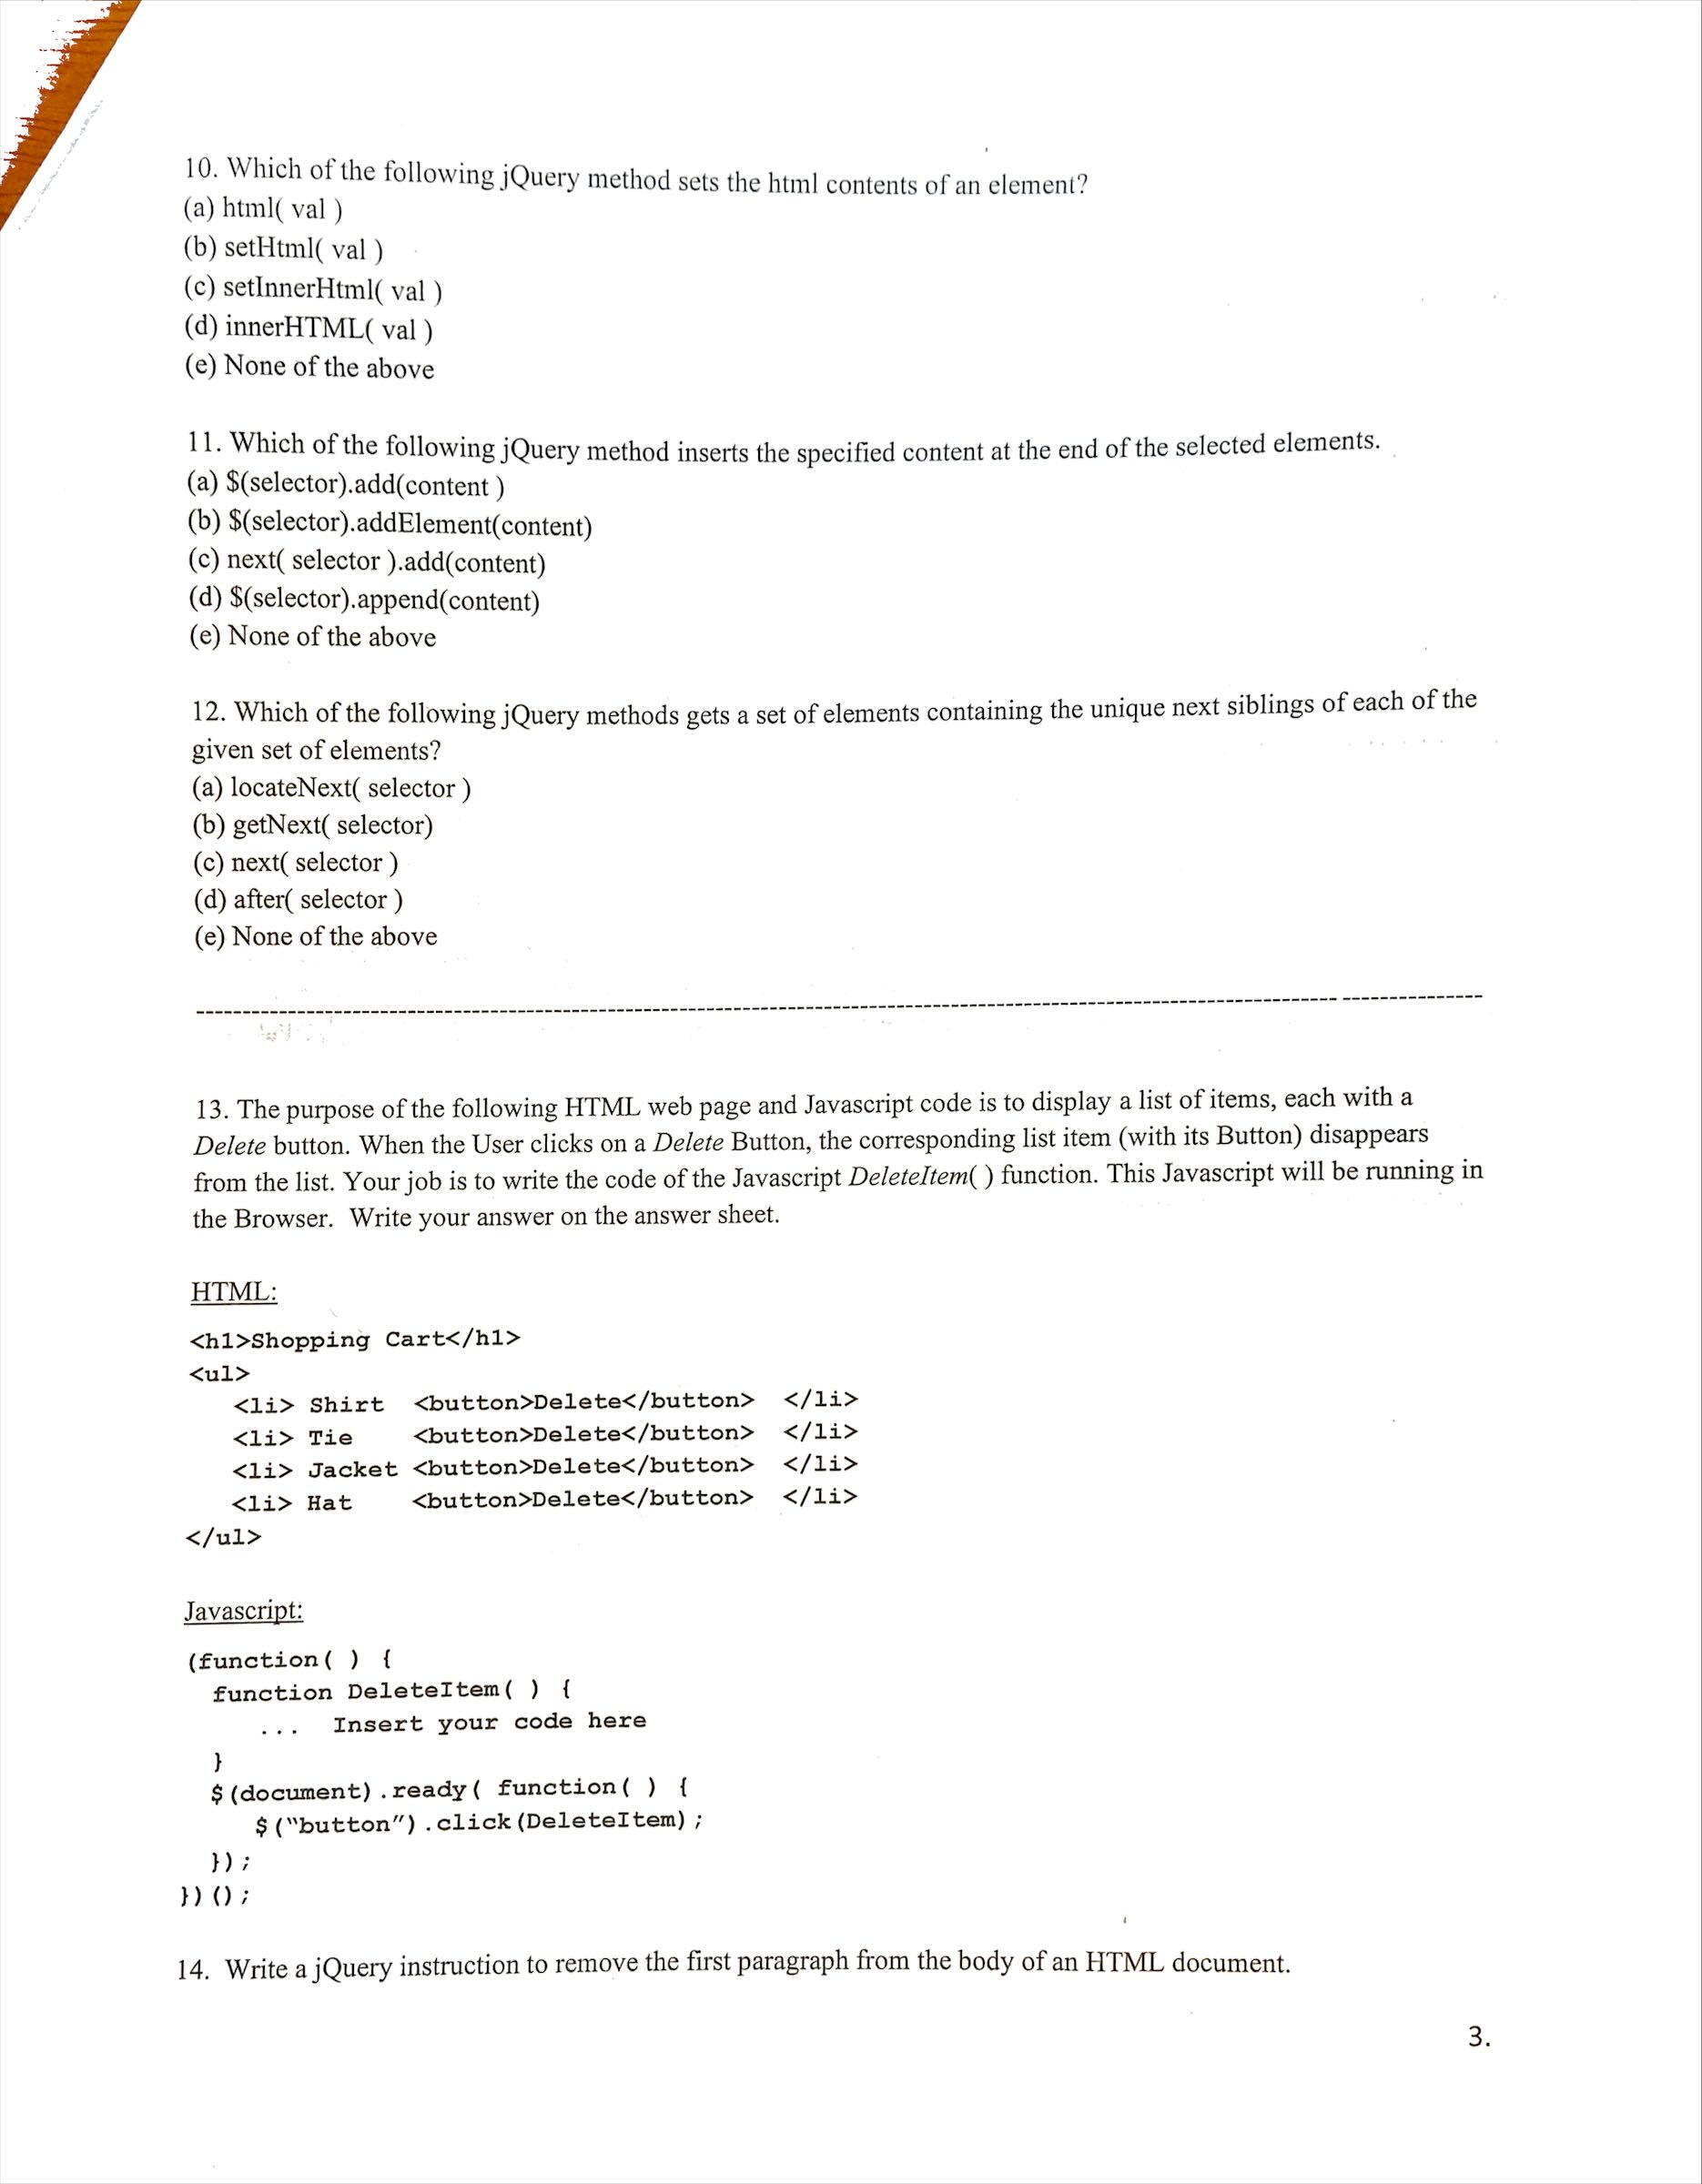

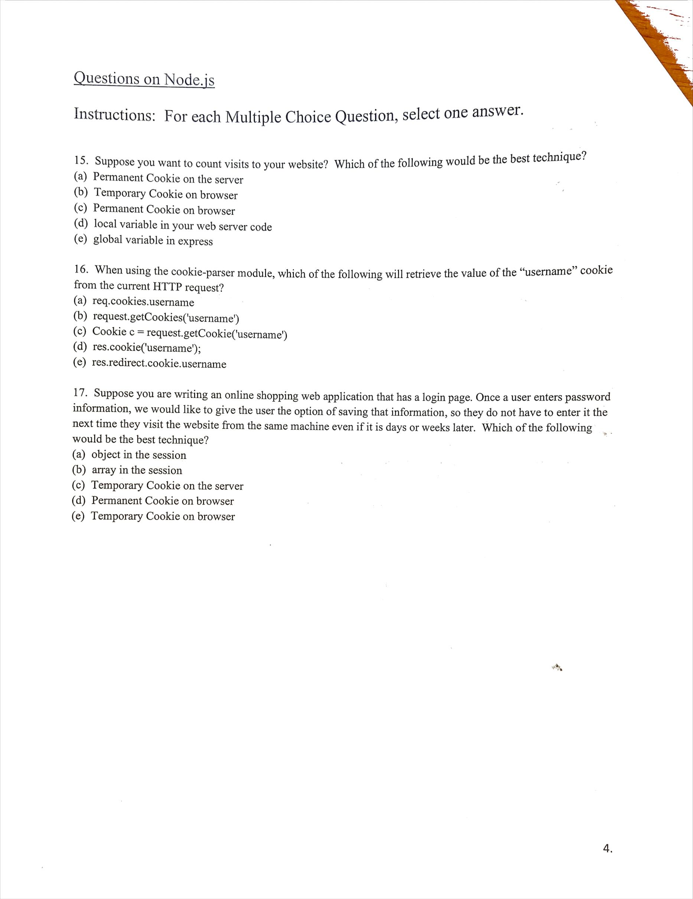

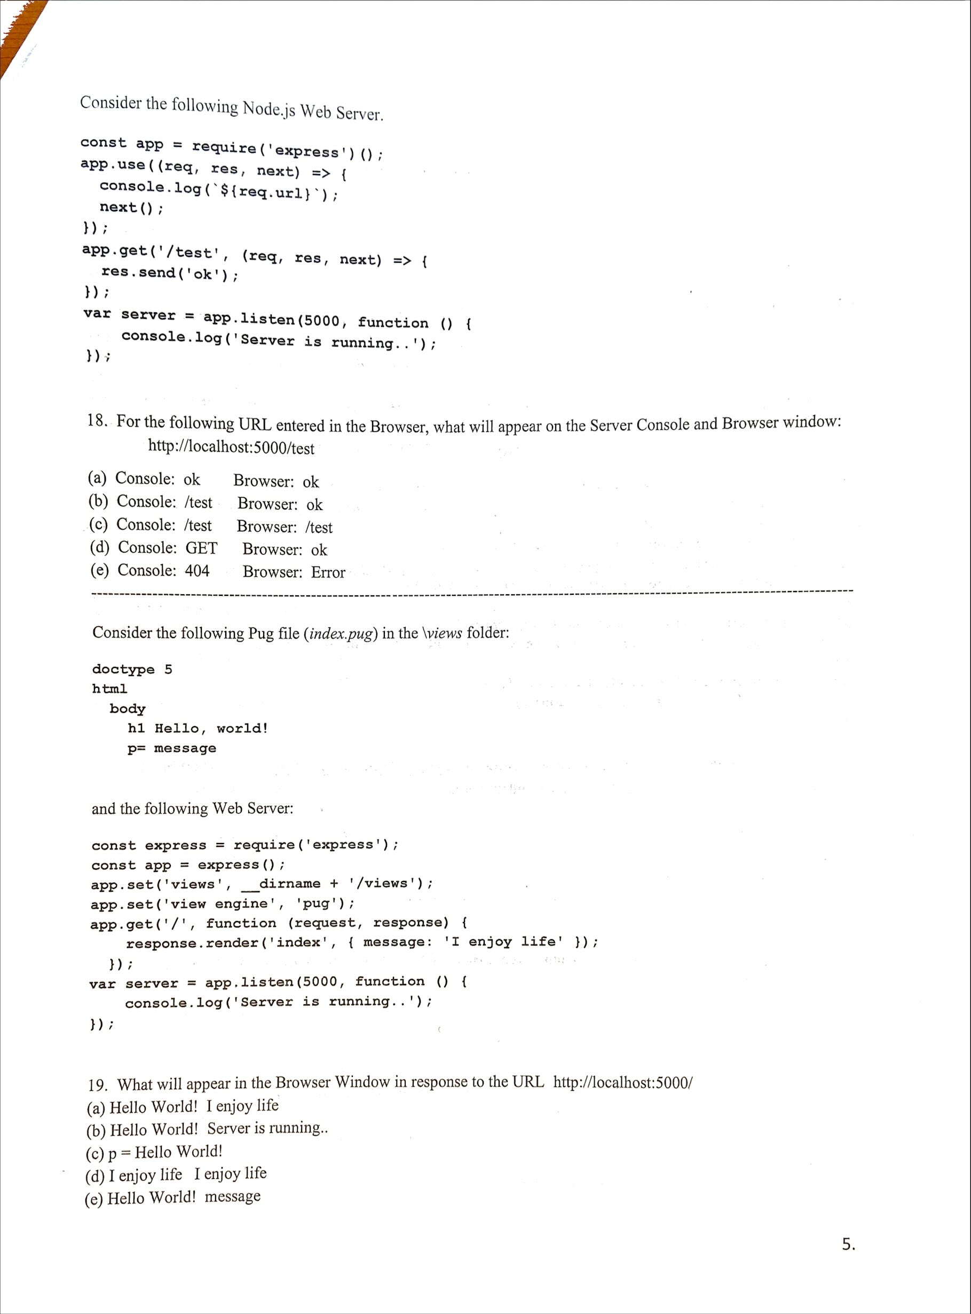

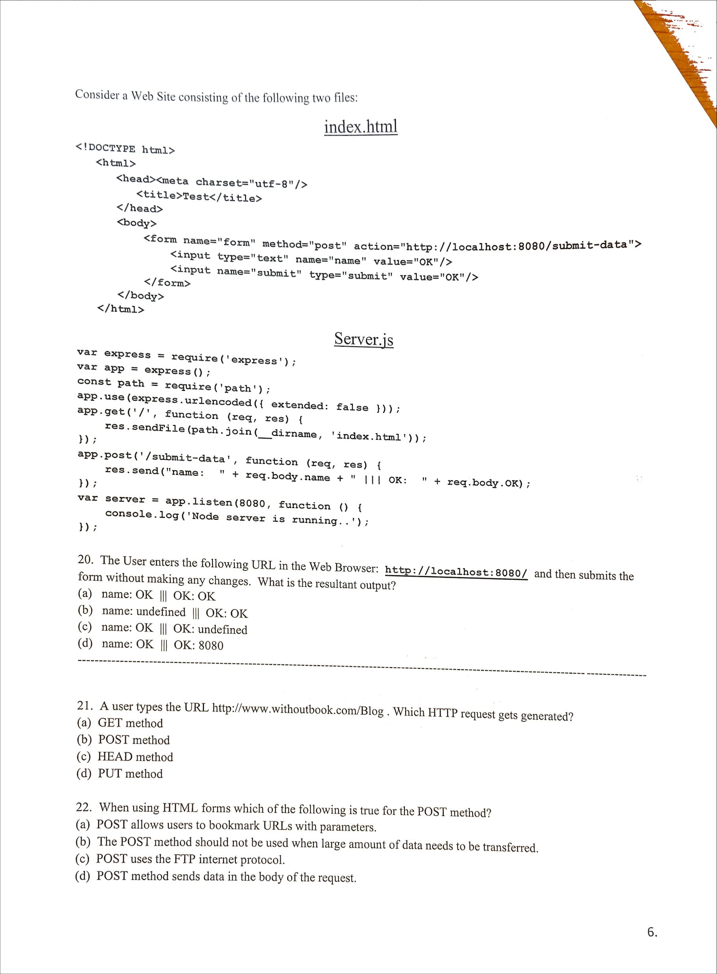

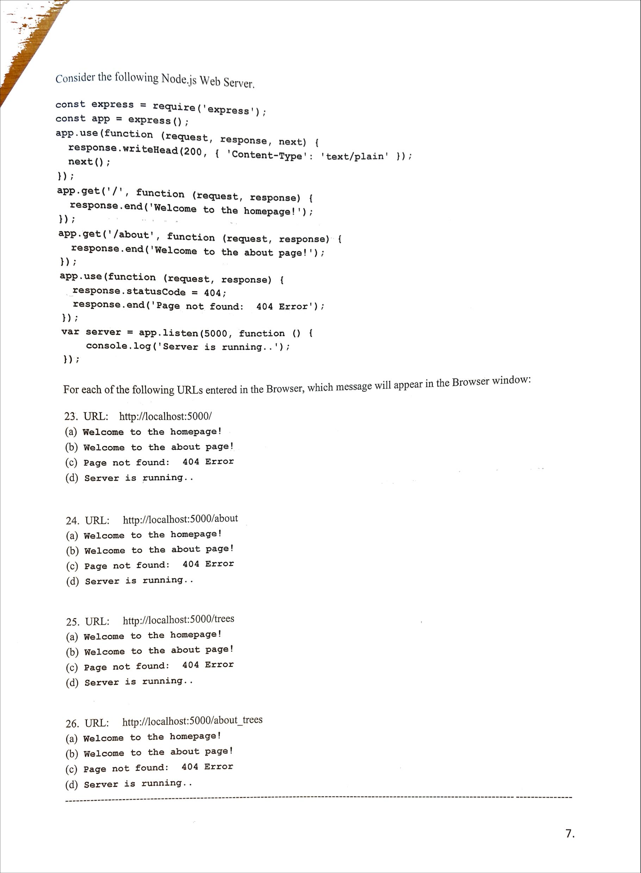

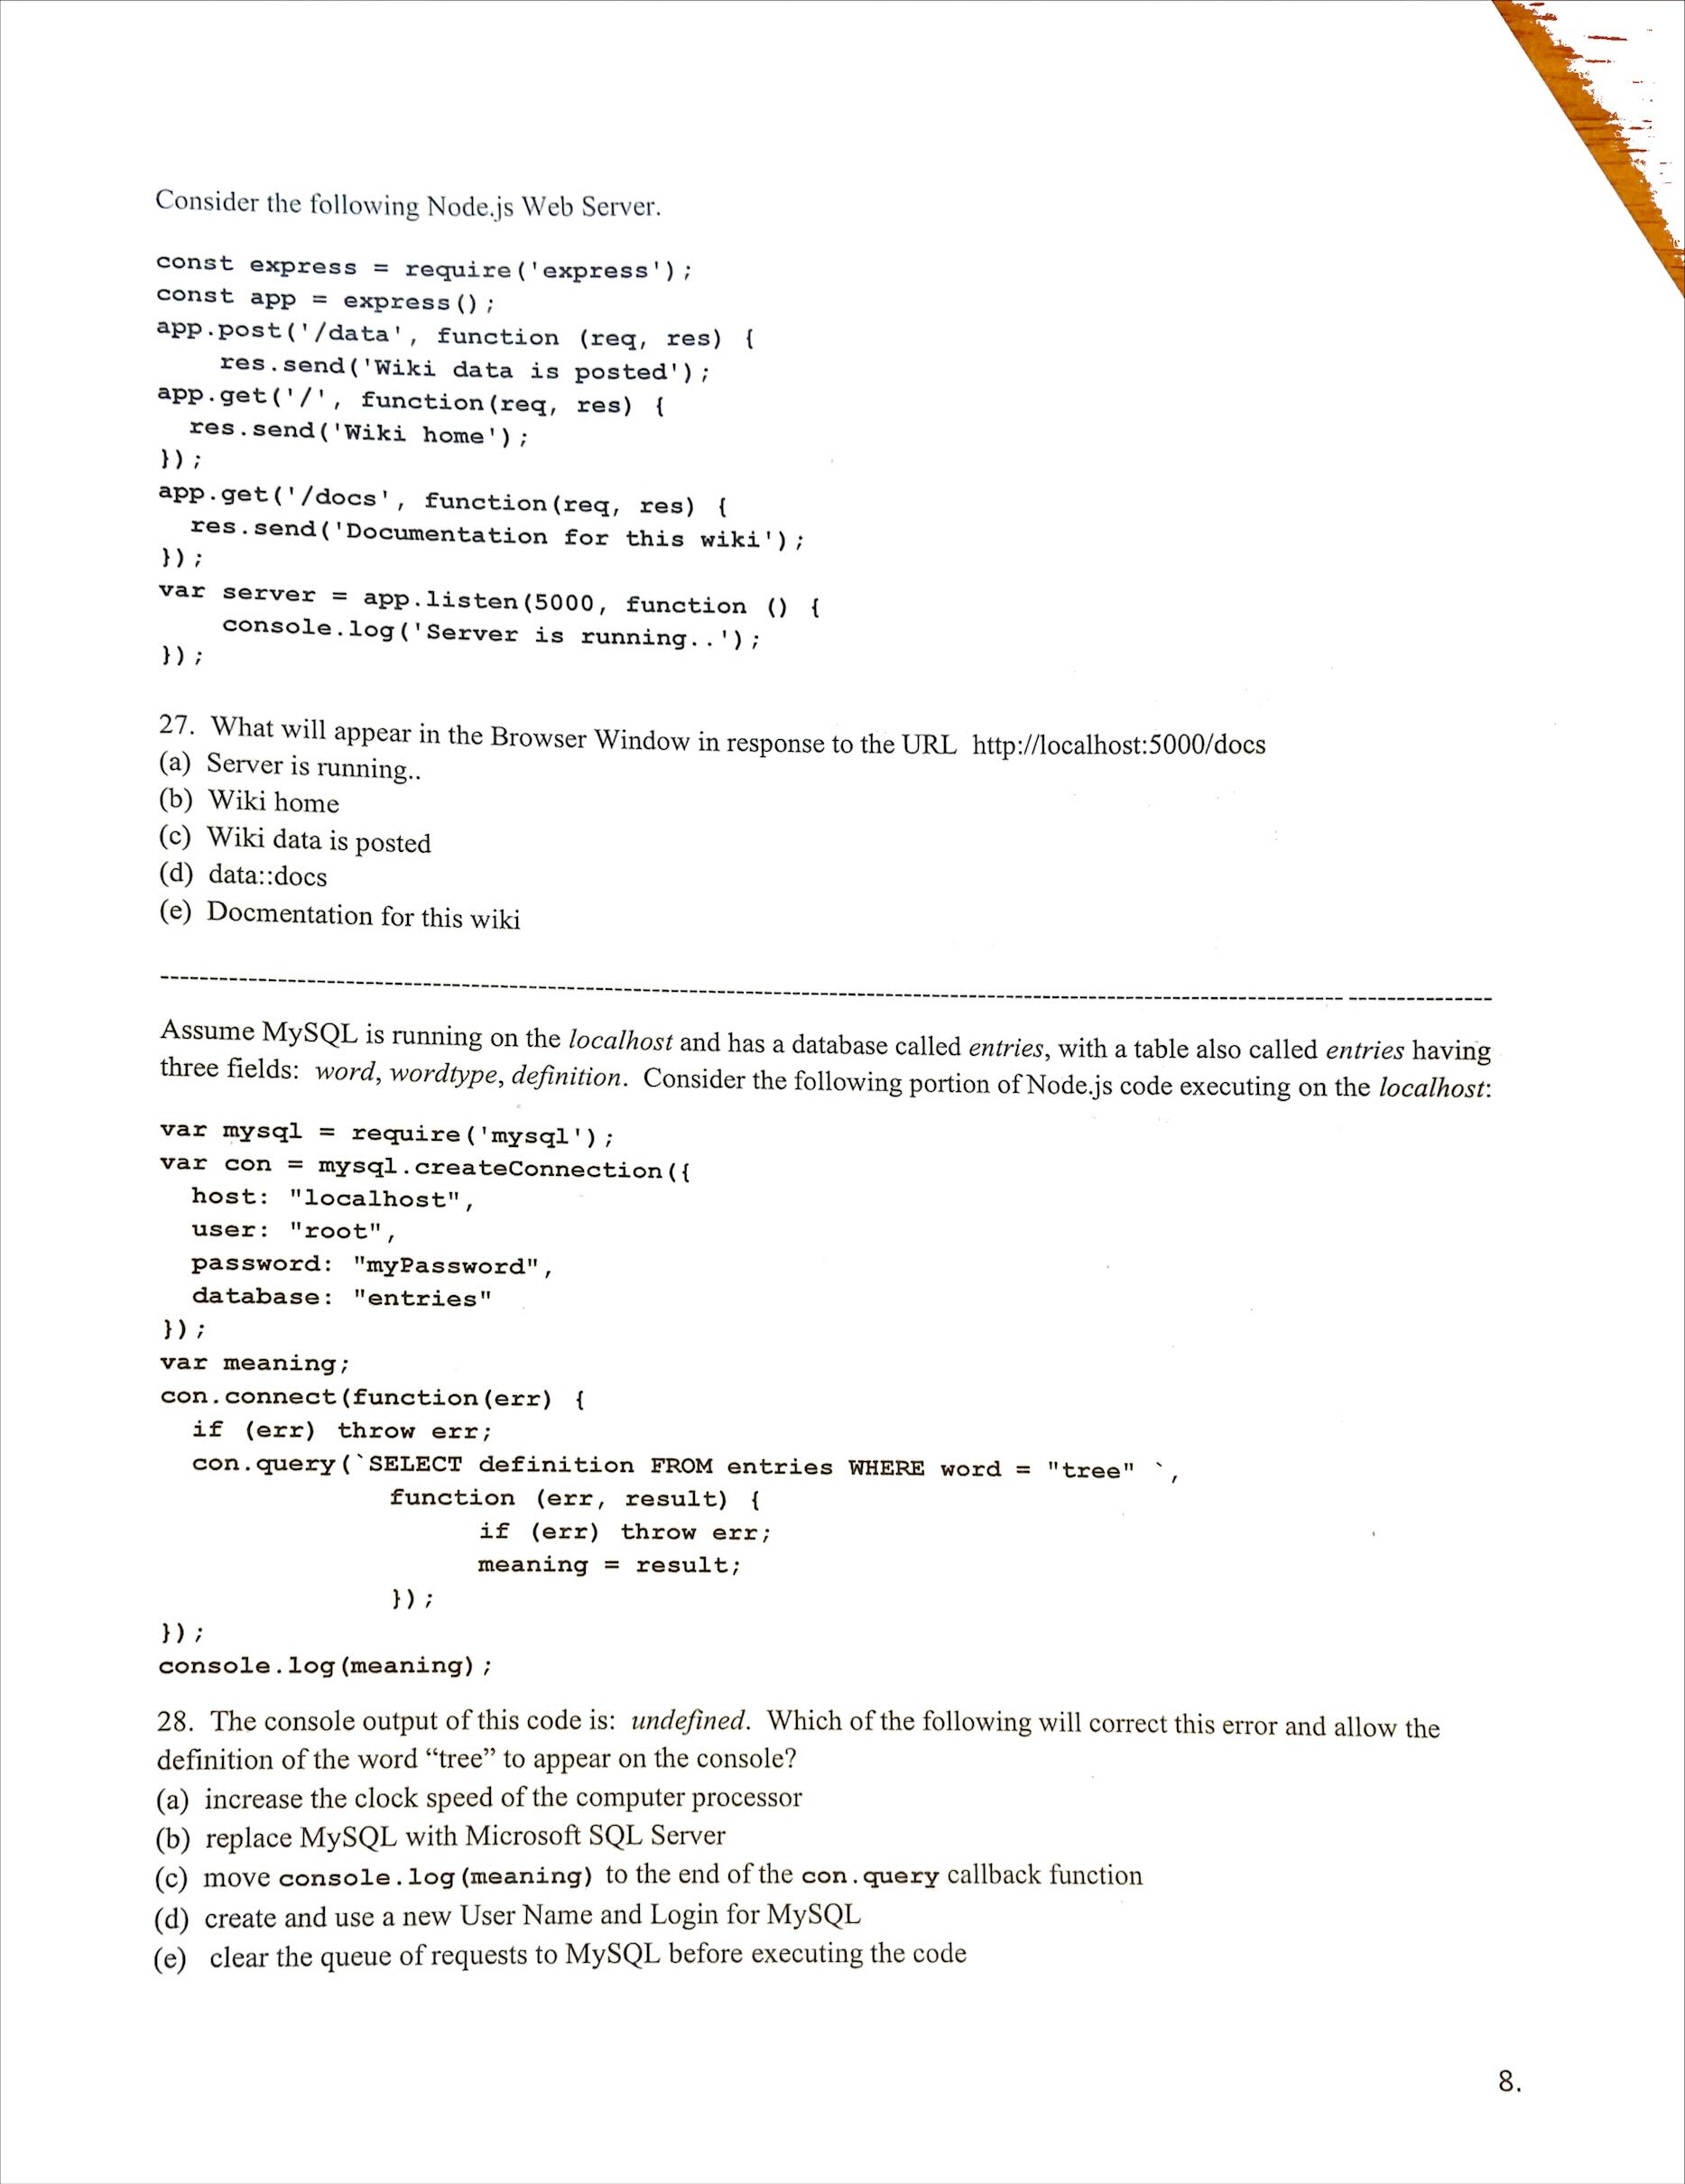

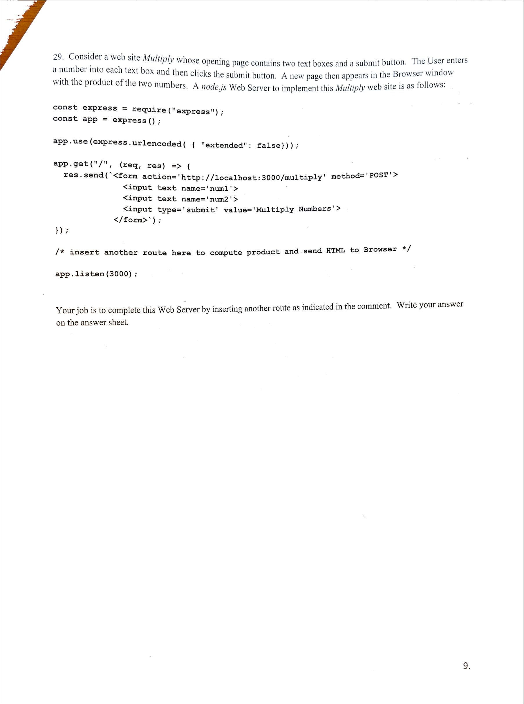app.post('/multiply',function(req,res){

const multi=(req.body.num1\*req.body.num2);

res.send(`<!DOCTYPE html> <html>

<head><meta charset=\"utf-8\"/> <title>Multiply</title>

</head> <body>

<p>The Answer is: ${String(multi)}</p> </body>

</html> `);

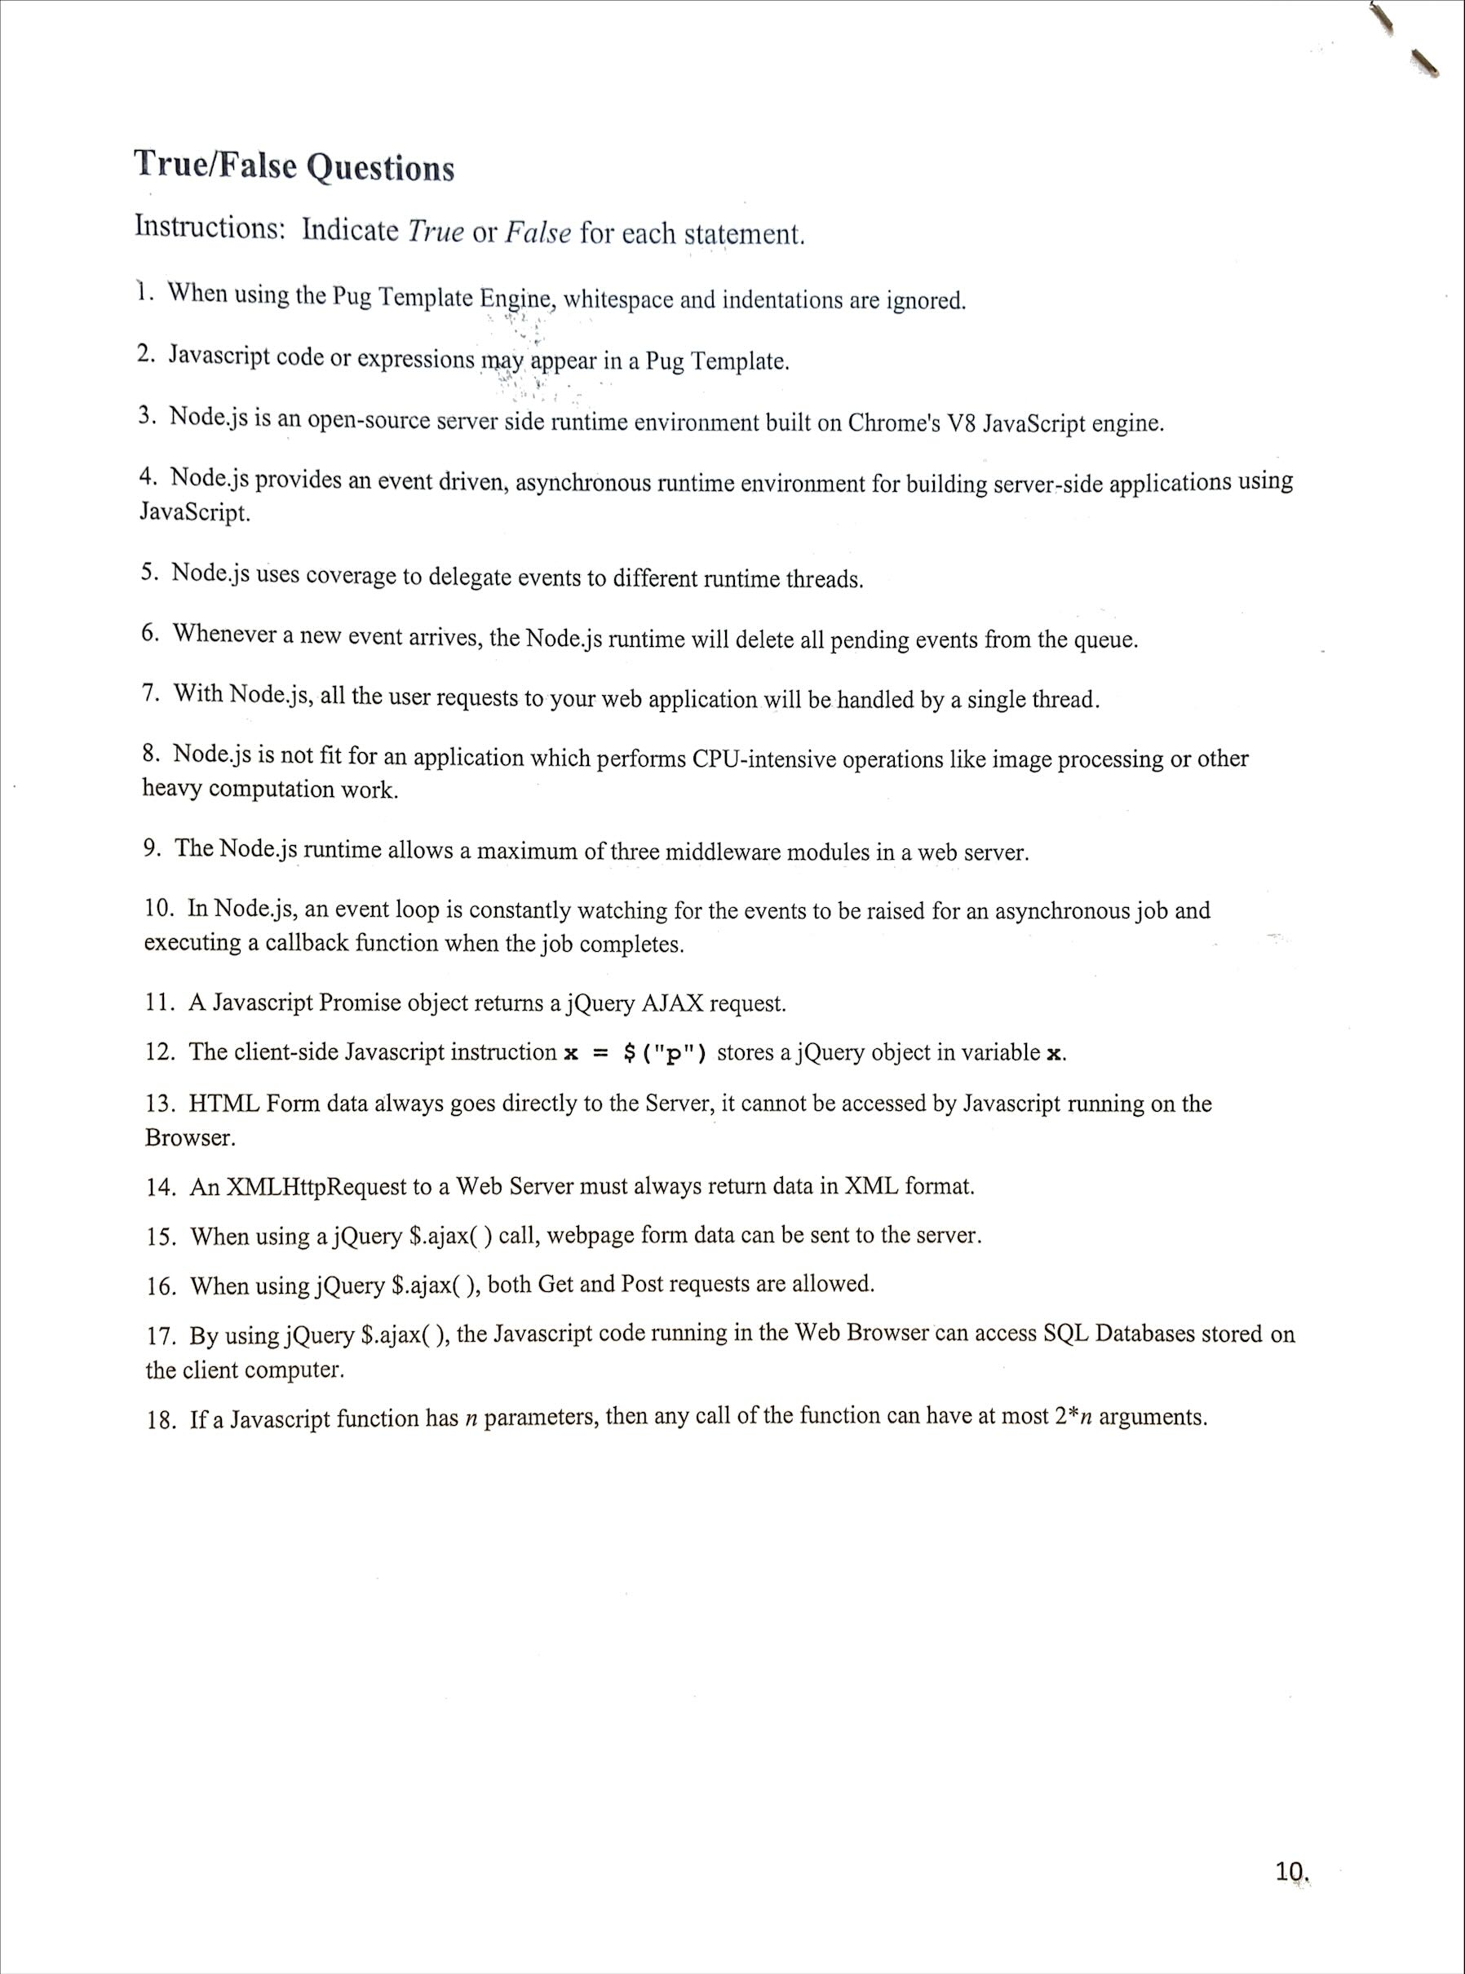F

T

T

T

T

F

T

T

F

T

F

T

F

F

T

T F

F